CONSTRUCTION EXHIBIT

GENERAL SPECIFICATIONS
ABC STORE
SMALL MARKET REMODEL

These specifications are all inclusive. Any deviation of product schedules or plans must have prior approval of ABC Board, before purchase or installation, in writing and will become part of the lease file. This building must meet all requirements of the "Americans with Disabilities Act" and must comply with all Local and State Building Codes. All work will be completed before acceptance. Owner will furnish any required licenses, permits or architectural drawings that may be required.

*All drawings must be submitted to ABC Board for approval before work begins. Before any changes are made the ABC Board must be notified for approval.
NO RENT OR UTILITIES WILL BE PAID UNLESS SALES CAN CONTINUE FROM THE WAREHOUSE AREA

GENERAL SPECIFICATIONS

NOTE:NO EQUALS WILL BE ACCEPTED. SOME ITEMS WILL HAVE ALTERNATES LISTED. ONLY THOSE ALTERNATES WILL BE ACCEPTED. WHERE ALTERNATES ARE NOT LISTED, ONLY THAT ITEM W1LL BE ACCEPTED. TIMELINE OF WORK TO BE SUBMITTED PRIOR TO BEGINNING OF WORK.

- If our current building is painted it is to be repainted or power washed ( ABC will decide.) If built of brick or stacked stone it is to be power washed. [If store is part of a strip-mall or shopping center front façade may remain the same for continuity of the shopping center] Any deviation from these specs must be submitted in writing and approved through the ABC Board Real Estate Division. All sidewalks are to be power washed.

- The parking lot must be constructed of heavy-duty asphalt and capable of supporting a fully loaded 53' trailer and add in length of the truck. Truck must have room to back up to the delivery door to unload from the rear or side of the truck. It is 24' from back of truck to the side door. This door will open outward flush with the wall. A metal awning will be required over this door and pipe bollards will be required to prevent the truck from hitting the awning and door.

- The parking lot must be striped on 9' (nine foot) minimum widths and include the required number of handicap spaces and signage. Construct handicap ramp as per ADA Standards. Parking lot will be clean before ABC will take occupancy. If store is located in a shopping strip and/or if parking becomes a problem, at least 3 parking spaces will be marked with a sign "ABC ONLY 15 Minute Limit."

- The entrance and exit doors will remain as long as they are in good working order. All hardware to doors must be in good working order. If they need to be replaced they are to be thirty-six inch (36") doors. If doors are double doors (no divider between doors). The exit door will open outward with outside hardware removed and entrance door will open inward with inside hardware removed. The bottom of the windows will begin at 2' (feet) above finished floor and extend above height of the doors. A metal awning will be required over all doors with adequate lighting. If burglar bars, pipe bollards, and/or a security roll down door(s) become necessary it will be at the landlord's expense. Install a 110v plug in the ceiling to the left of the entrance door separating warehouse and sales area.

- Current sales area walls must be primed and painted with (2) coats Sherwin Williams #7642 Pavestone Eggshell enamel. Warehouse and restroom walls are to be painted with Sherwin Williams Pro Mar 200 Egg Shell Extra White B20-W-4451. All walls must be smooth and free of any offsets or protrusions and debris.

- Current divider wall that separates the sales area from the warehouse area to remain. Install 36" wide x 7' Eliason self-closing pivotal metal door, Model #LWP3 with window.

- Extend current elevated office in the sales area to 16' L x 6' W (inside to inside). This could change depending on the number of cash registers to be used (determined by ABC). The office floor is to remain at the current height above the finished concrete floor. The walls are to be raised to six (6') high above the finished concrete floor. The walls are to be raised by installing framed plex-glass attached to top of the wood on existing office walls. The short end of office will have a frosted tint on plexiglass. The office steps are to be moved 90 degrees so they will be behind the cashier instead of at end of office. If there is a window wall in the office area the window is to be a frosted tint and in cash register area the same tint or blinds will be required to block view from the outside. If the direction of the store presents an issue with glare from the sun it will be required to install blinds. Furnish and install a built-in work station in the office area. It will be L shaped with 3 supports and a built­ in pencil drawer. The pencil drawer will be l6"D x 29"W x 4"H. The drawer back must be at least 3" from office wall. The top is to be Black Matte Formica. The bottom of the desk "can be no lower than 32". At the end of the desk enough room must be made to accommodate a Safe- 18 1/2" D x 20"W x 30 1/2 H. There must be at least 30" at the end of the desk facing the sales area for the safe to fit. (We will furnish 2 file cabinets 29" tall to fit under each end). We will supply drawing.

- Office trim will be smooth wood tops of l" x 8" with a l" x 2" bottom trim. Round all sharp corners for safety. Install chair rail of l" x 8" x10' sanded smooth on the back wall of the office. Mounted 36" centered from floor of office. All wood trim throughout sales area and office will be stained with Min-wax English Chestnut and sealed with 2 coats of clear Min-wax polyacrylic. Nail heads and seams to be puttied with like color of wood.

- Wiring to counter from office will run in a chase along bottom of window wall. All electrical and data lines shall be placed in chase with pull lines at checkout location. If wiring to office runs over-head then it needs to run behind and under the office wall and through chase to the checkout counter. The check-out counter will be provided and installed by the Landlord. The counter must be boxed in with one adjustable shelf and a 16" Dx 20" W x 4"H pencil drawer for each cash register. The drawer has to be at least 3" off the back wall. The tops of the counters will be covered with Black Matte Formica with 2" overhang. The counter front and ends will be covered with a heavy gauge bronze corrugated metal (see Check Out Counter Specs) this will be a decision made by ABC. The shape and length of the counter will be determined by ABC Board (depending on number of cash registers to be used). A 2” hole is to be cut behind the pencil drawer in order to have access to electrical outlet. ABC will point out location on counter)

- Interior lighting is to be updated with 2 x 4 LED lights with 5000 lumins or better. Lights are to be patterned six (6) feet apart side by side and four (4) feet apart end to end.

- Upgrade current suspended ceiling with white 2' x 2' or 2’ x 4’ tile by painting ceiling grid white if stained or faded. Replace all broken, stained or bowed ceiling tiles. Ceiling should be ten feet (10') above the floor in the sales area. In the warehouse and restroom area the ceiling tiles and grid will be white. Building must have a minimum of six inches (6") of insulation (R-19) in entire building. In some cases an open ceiling will be used an R-19 insulation factor must be achieved. NOTE: Restroom ceiling will be 8' AFF.

- If current HVAC unit is less than ten years old it will not need to be upgraded at this time. However, when current HVAC units reach the ten year mark the landlord will be required to install the below listed energy efficient HVAC. The landlord is required to show proof of age of current HVAC. Install HVAC to adequately heat or cool the entire area in any extreme weather condition (units will be energy star rated with a SEER rating of 15). For every 350-400 square feet, you need a one-ton unit. For example, 2000 sf required a 5-ton unit (unless there is glass all the way across the front in which case a bigger unit may be required). Air vents and returns must be ceiling mounted (black in sales area). Air vents and returns in the warehouse will be white. Air filters for the HVAC are rated MERV 8 and are changed quarterly by the Landlord. NOTE: Install programmable thermostats. The warehouse thermostat should be mounted within 12" of the divider wall door on warehouse side. The sales area thermostat should be mounted in the office.

- Extend current 3/4" x 4' MDF fire rated plywood backboard to 12’feet (painted with black paint) and install additional quad plugs to board as required below. Mounted horizontal adjacent to the electrical panel for phone, alarm system and computer server installation. This board will be mounted 60” above finished floor and must be installed as soon as possible. Provide weather head pipe through wall for phone line adjacent to this panel. Pipe must be a minimum of 10' above exterior grade. In areas where the phone line comes into the building from underground, a metal 4" conduit must be provided (with pull string) so no phone wire is exposed on the exterior. Plywood backboard must have a grounded buss bar, four (4) NEMA 5-20 quad outlets with a dedicated circuit to each quad outlet, surface mounted across the bottom of the ¾” MDF backboard. Reference backboard drawings for additional details. Install standard outlets in warehouse and sales area every 12' to 15' feet if code requires. In the warehouse area mount these plugs minimum of 36" above finished floor. The light switches in the warehouse will be mounted within 12" of the warehouse door and an electrical outlet will be mounted below these switches at the same height as the rest of the outlets. The outlets on sales area wall are standard plugs at normal height.

- If this is not currently in place then Landlord will coordinate, order, and fund installation of Entrance Facility Construction (EFC) for ATT Switched Ethernet (Fiber) and Copper POTS (Telephone) infrastructure to the 3/4” MDF Backboard designated by ABC for the Network Terminating Equipment (NTE). ABC will order and fund ATT services once EFC is complete. Landlord is responsible for coordinating with ATT to determine the minimum requirements needed for EFC. In the event that ATT is not a local provider for the proposed location, landlord must notify ABC and the ABC IT Department will facilitate installation efforts between landlord and ATT. EFC consists of conduit, other support structures or physical pathway necessary for the installation of AT&T Switched Ethernet and Copper POTS circuits from the property line of the premises where the entrance facility is to be constructed (Premises) to the Minimum Point of Entry (MPOE) of the building where the NTE is located, and includes the following:
  - Entrance Facility required to provision AT&T Switched Ethernet Service and Copper POTS from the property line of the Premises to the MPOE
  - Core drilling and weatherproofing of the Entrance Facility
  - Interior Raceway/support structure if required for placement of AT&T-provided NTE
  - Backboard for mounting NTE
  - Dedicated power outlet and ground for NTE.
  - Landlord must secure all necessary third-party approvals necessary to provide EFC

- Current warehouse exit door is to remain if it meets the listed requirements below. Warehouse door to be a hollow steel commercial security door with NRP (non-removable pin) hinges, a thumb deadbolt and ADA lever door handle at rear of building, this door will also have a lock guard on the exterior. This is to prevent the door from being pried open. This door will be thirty-six (36") wide and must be installed in the door opening to allow it to open flat against the outside wall. Wall spacing for lock side must meet ADA requirements. An awning will be required over this door. Bollards filled with concrete will be required to keep deliver truck from damaging the awning. Install a steel security bar on the inside of this door. Model Exit Security #SB0l 0042A (Vendor - Tri-State Door Company, P.O. Box 177, Hartford, AL 36344, Phone (334) 588-3462; or direct from Vendor: Exit Security, Inc., 1-800-446-6775.)

- Current restroom is to include tissue holder and ADA mirror above sink. Restroom doors to be three feet (3') wide. Install necessary equipment needed for the handicapped, including assist bars (side, rear, and vertical), insulation on pipes under sink, lever type door handle. If only one restroom is required a urinal must be installed if required by code. All restroom equipment will be energy star rated including the hot water tank in the corner mounted over the mop sink. (If hot water heater is older than ten years it is to be replaced as listed above.) All internal parts of toilets are to be upgraded.

- Building, parking lot, all glass, floors, and counters will be cleaned; before ABC will take occupancy.

- If zoning or city ordinance requires garbage dumpsters to be utilized, owner will furnish and install a concrete dumpster pad and fencing per specifications provided by governing authority. ABC must be consulted on location of dumpster pad.

- All landscaping, irrigation meter (when required) shrubbery, grass and trees will be furnished and maintained by Landlord throughout the terms of this lease.

- A secured outside freeze proof wall hydrant will be required on the front of the building if a fauset/wall hydrant is currently installed.

- Any mold remediation due to leaks will be the responsibility of the landlord. This will be throughout the term of the lease.

- All pest control interior and exterior of the building will be furnished and maintained by the Landlord throughout the terms of the lease.

- Furnish and install mailbox and post if necessary as required by local postal service.

- All door locks are to be re-keyed in presence of ABC store personnel and (4) keys given to ABC personnel on liquor delivery date or day of acceptance.

- "SELECT ABC SPIRITS" sign and metal awning must be furnished, installed, and maintained by the landlord during the term of the lease. The size of the signs will be to local code; however, the design of the sign must be adapted in accordance with local zoning laws. (See attached Sign Specifications for size and color). ABC must be notified if there are any changes to the sign for prior approval. These signs will be controlled with dusk to dawn photo cell direct wire to panel. (Note: NO TIMERS) A pole sign and marquee sign will be required if the building visibility is limited from the street. Final design must be approved by the ABC Real Estate. Sign must be up and operational one week before acceptance of the store. The sign will be maintained during the term of the lease by the Landlord. Note: In the event that ABC vacates the premises the Landlord shall be responsible for removal of the signage within 30 days. Type of sign to be determined by ABC.

- As per Fire and Safety, at least two fire extinguishers will be installed and maintained throughout the term of the lease by the Landlord.

- Current windows to remain as long as all windows are in good shape.any broken or cracked windows are to be replaced with energy star rated U-Factor less than or equal to 0.60 and SHGC less than
or equal to 0.27 and be certified by NFRC. (When windows are purchased information should be
on the window.) \

- In hurricane prone areas, hurricane shutters will be required and maintained by the Landlord.
These shutters must be on the outside of the glass to prevent damage to glass. It will be the Landlord’s
responsibility to insure they are in place during a severe weather event. If city or county code
requires hurricane rated windows, they are to be installed to meet code.

- Electric roll down security doors to cover front windows and doors will be required in some areas; it will be the decision of ABC. These doors will be maintained by the Landlord throughout the term of the lease.

- Must install vinyl wood grain flooring in the sales area, office, and restrooms. (See floor covering specs)

- Metal awning to be installed and maintained throughout the term of the lease. The awning will be required over all doors and windows with adequate lighting.

- If using a metal roof, a cool seal coating shall be applied.

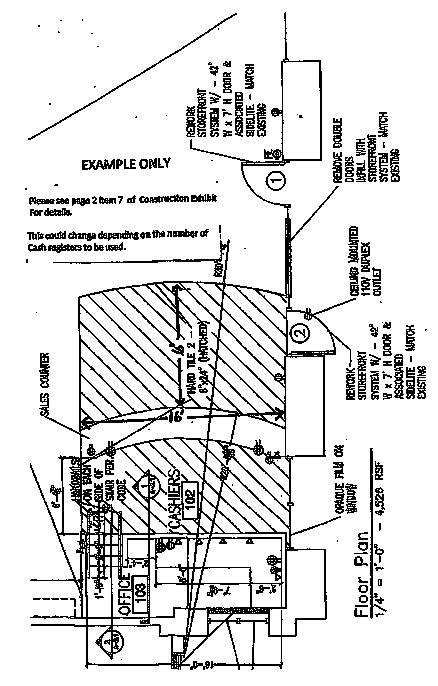
ELECTRICAL

NOTE: NO EQUALS WILL BE ACCEPTED. SOME ITEMS WILL HAVE ALTERNATES LISTED. ONLY THOSE ALTERNATES WILL BE ACCEPTED. WHERE ALTERNATES ARE NOT LISTED, ONLY THAT ITEM WILL BE ACCEPTED.
*All light fixtures must be LED lighting with 5000 lumins or better throughout the interior of the building. If the building has an open ceiling. Wall packs need to be LED wall packs. Lights that are in or under the awning need to be LED also. HVAC units need to be a minimum of SEER 15 and Energy Star rated, and that all air filters are rated MERV 8 and are changed on a quarterly basis by the Landlord. Programmable thermostats need to be installed. Stores with natural gas heaters are to be fuel-utilization-efficiency (AFUE) rating to 80 percent and controlled by a programmable thermostat. All Light fixtures and bulbs in addition to Filters and Signage will be the responsibility of the Landlord during the term of the lease.

*Landlord is responsible for ordering power to the building (and gas when necessary).

*Due to new regulations from the Governor's office all leased state property must comply with the new energy saving rules. All electrical, gas, lighting, HVAC, toilets, and signs must meet these new rules and it is Landlord's responsibility to comply and will be held responsible for the maintenance of said throughout the term of the lease.

- Install and maintain interior lighting. It will be 2’ x 4’ LED 5000 lumins or better. Pattern the fixtures with six foot (6') width between fixtures and four foot (4') between lengthwise. Install one
(1) fixture in each restroom. Two fixtures in the center row of sales area and two in the warehouse will be unswitched for night light. Fixtures unswitched in sales area and warehouse will be one left and one right of the warehouse door. Light covers are to be clear with diamond cut texture.

- Provide wiring as needed for sign, plumbing, HVAC, interior, exterior, and pole lighting, per 2014 NEC code. It is the Landlord's responsibility to maintain all lighting during the terms of the lease this includes all bulbs, ballasts and light covers.

- Electrical and data wiring to checkout counter from office will run through a chase at the bottom of the window wall. Electrical and data lines shall be placed in conduit with pull lines installed. If wiring runs over-head then it needs to be ran in conduit above the ceiling tiles, behind the office walls and thru the chase to reach the checkout counter. Install minimum 3” diameter conduit above ceiling tiles with pull string from the communications backboard to the office for over-head data lines. Install ¾” conduit behind the walls providing cable paths to the data outlets located in the office and checkout counters using a dedicated ¾” conduit (Rigid Metal or PVC) one (1) per outlet with pull string, no flexible metal conduit. Any 90 degree bends require a sweeping bend or an accessible pull/junction box.

- Install LED combo units Exit/Emergency light above all doors as per code and Fire Marshall. Install all required LED emergency lighting as per local codes in sales and warehouse area to be maintained by the Landlord during term of lease.

- Outside lighting must be adequate to provide maximum safety. All lighting will be provided and maintained by Landlord. Remove existing outside light(s) and install security wall packs with LED 150 watts. No timers, photo cell only. If it is a free-standing building and there are no pole lights there must be a 150 W LED flood light on each corner of the building and 2 security wall packs with LED 150 watt lights on the front under the awning. Must install lights over parking areas. If there are parking lot pole lights, then the lighting will need to be two (2) 150 W LED flood lights at least one pole in the rear of the building and two poles in the front of building. Install LED Wall Packs on each corner of the building with two (2) on the front, under awning. No timers, photo cell only. Install one (1) junction box above ceiling for the main sign with disconnect wiring to sub panel. In the event the store requires a Pylon sign provide circuit breaker and conduit. No timers, photo cell only.

- Install exhaust fan in restrooms switched separately from light. Vent exhaust through exterior wall (by mechanical contractor).

- Install one (1) standard NEMA 5-20 duplex outlet at each end of checkout counter. Placement will be on the inside of checkout counter.

- The computer cash register has special wiring requirements. Install one (1) NEMA 5-20 quadruplex receptacle on its own dedicated circuit and one (1) single gang empty data outlet (with pull string) in checkout counter (mounted on the back wall under the drawer) for each cash register and one or more in the office on the short end of built-in desk. Each one must be isolated.

- Install four (4) duplex NEMA 5-15 receptacles each on their own dedicated circuit and four (4) single gang data outlets (with pull cords) all evenly spaced above the desk top and just below the trim of the wall in the office. Install one (1) duplex NEMA 5-15 outlet and one (1) single gang data outlet (with pull cord) on the short end of the desk. Install one (1) NEMA 5-15 duplex outlet mounted on back wall above chair rail.

- Light switches for sales area will be in the office on the front wall just below the trim of the wall. The light switch will be positioned first as you enter the office at the end of the desk, nothing will be mounted past the end of the mounted desk.

- Extend current a ¾"x 4' x 4 to 4’ x 12’ MDF plywood backboard (painted with fire rated paint) mounted horizontal adjacent to the electrical panel for phone, alarm system and computer server installation. This board will be mounted 60" above finished floor and must be installed as soon as possible. Provide weather head pipe through wall for phone line adjacent to this panel. Pipe must be a minimum of 10' above exterior grade. In areas where phone line comes into building from underground, a metal conduit must be provided (with pull string) so no phone wire is exposed on the exterior. Plywood backboard must have a grounded buss bar, four (4) NEMA 5-20 quad outlets with a dedicated circuit to each quad outlet, surface mounted across the bottom of the ¾” MDF backboard. Reference backboard drawings for additional details. Install standard outlets in warehouse and sales area every 12' to 15' feet. In the warehouse area mount these plugs a minimum of 36" above finished floor. The light switches in the warehouse will be mounted within 12” of the warehouse door and an electrical outlet will be mounted below these switches at the same height as the rest of the outlets. The outlets on sales area wall are standard plugs at normal height. If there is a common electrical or data room for a multi-tenant strip center, a 4" metal conduit with pull string must be provided from the fire rated plywood panel to the data panel.

- If this is not currently in place then Landlord will coordinate, order, and fund installation of Entrance Facility Construction (EFC) for ATT Switched Ethernet (Fiber) and Copper POTS (Telephone) infrastructure to the 3/4” MDF Backboard designated by ABC for the Network Terminating Equipment (NTE). ABC will order and fund ATT services once EFC is complete. Landlord is responsible for coordinating with ATT to determine the minimum requirements needed for EFC. In the event that ATT is not a local provider for the proposed location, landlord must notify ABC and the ABC IT Department will facilitate installation efforts between landlord and ATT. EFC consists of conduit, other support structures or physical pathway necessary for the installation of AT&T Switched Ethernet and Copper POTS circuits from the property line of the premises where the entrance facility is to be constructed (Premises) to the Minimum Point of Entry (MPOE) of the building where the NTE is located, and includes the following:
- Entrance Facility required to provision AT&T Switched Ethernet Service and Copper POTS from the property line of the Premises to the MPOE
- Core drilling and weatherproofing of the Entrance Facility
- Interior Raceway/support structure if required for placement of AT&T-provided NTE
- Backboard for mounting NTE
- Dedicated power outlet and ground for NTE.
- Landlord must secure all necessary third-party approvals necessary to provide EFC.

- Install programmable thermostats. The warehouse thermostat should be mounted within 12" of the divider wall door inside warehouse. The sales area thermostat should be mounted in the office.

- If coolers are required, a plug on each side of the coolers must be mounted in the warehouse. (Not all stores will have coolers).

- If a 110V plug is currently installed in the ceiling it is to remain. If not it is to be installed to the left of the door separating the retail from the warehouse areas.

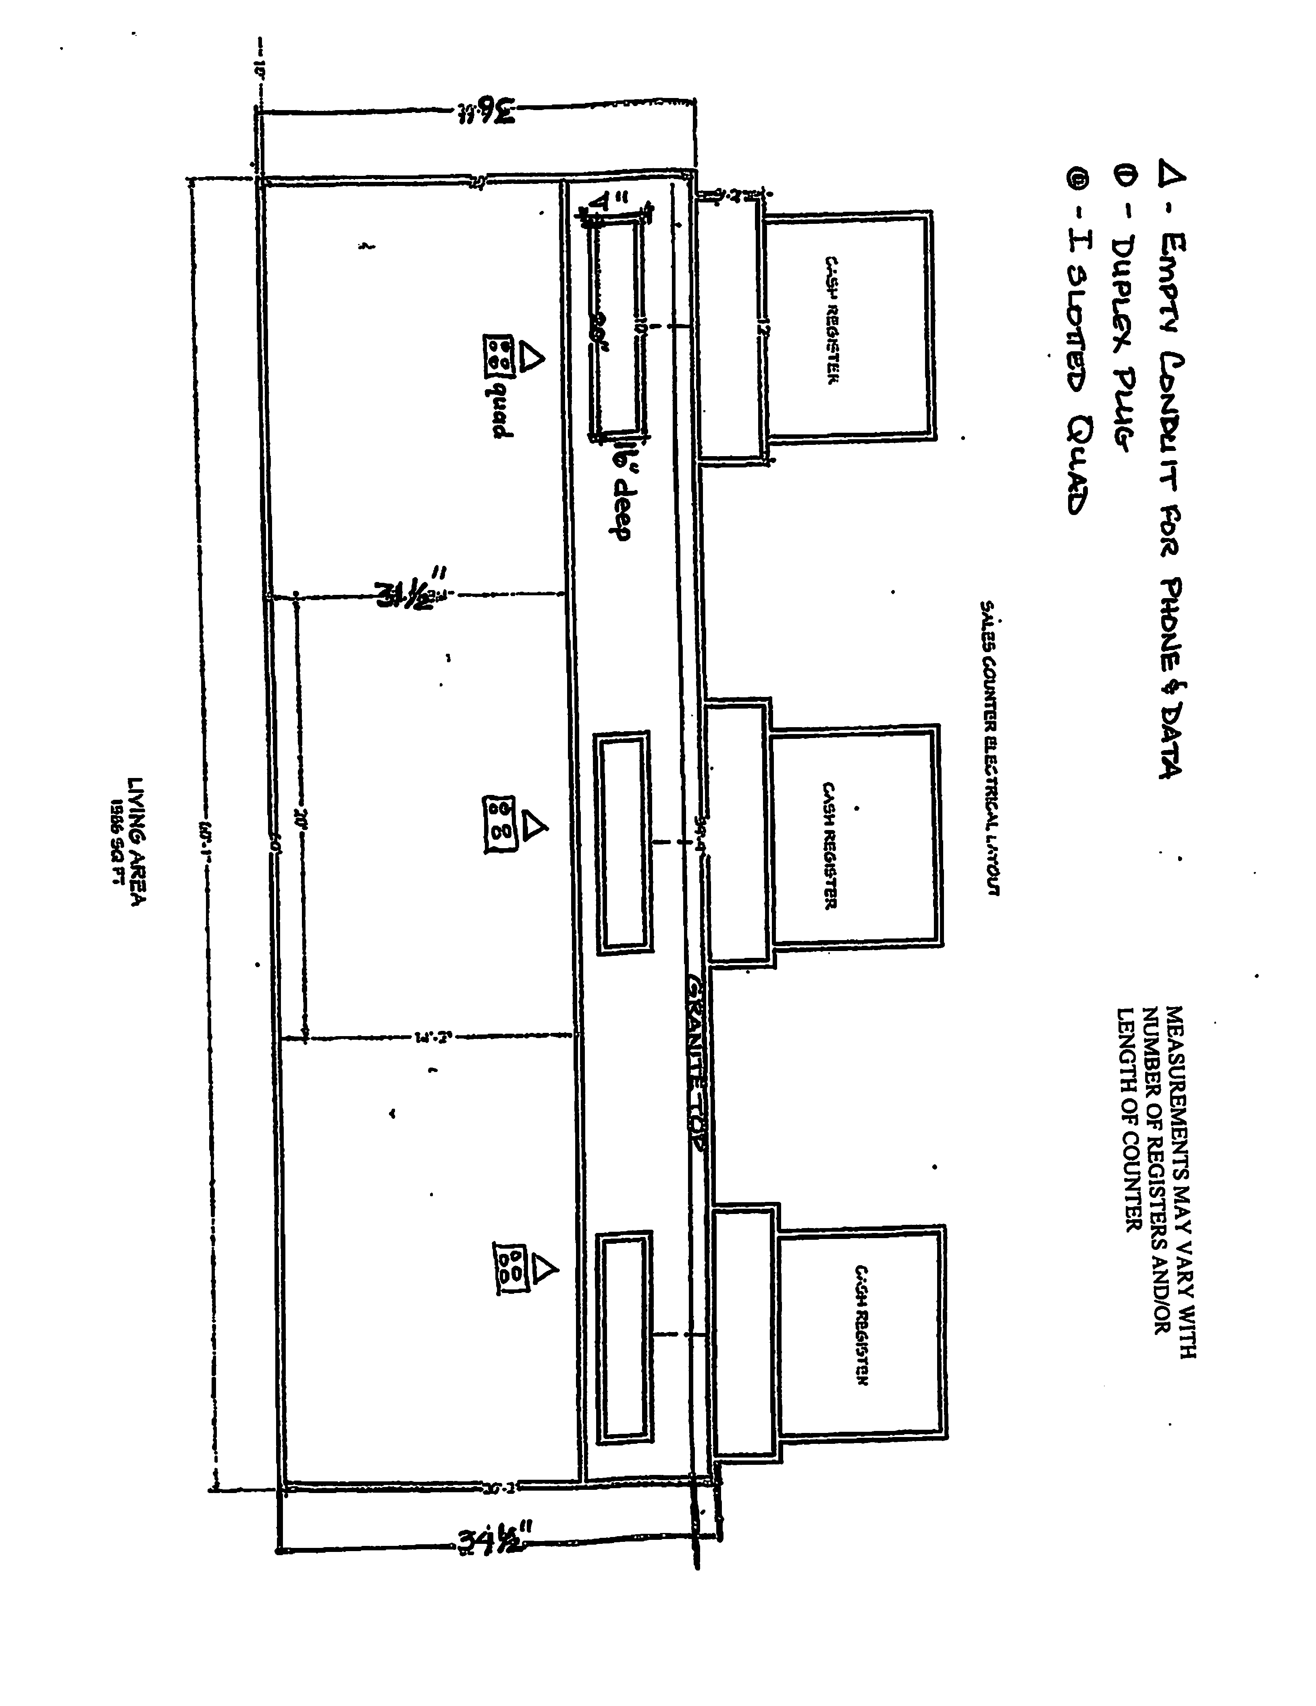
FLOOR COVERING

NOTE: NO EQUALS WILL BE ACCEPTED. SOME ITEMS WILL HAVE ALTERNATES LISTED. ONLY THOSE ALTERNATES WILL BE ACCEPTED. WHERE ALTERNATES ARE NOT LISTED, ONLY THAT ITEM WILL BE ACCEPTED.

- Install a wood grain waterproof interlocking luxury vinyl plank flooring with pad (6 x 36 Winding Brook-4.4 MM-6Mil-2.39sq ft at Home depot) or a glue down wood grain waterproof vinyl plank flooring if on a concrete floor in the sales area, office and restroom floors (to include supervisor's office and break area if applicable) with pattern design running in same direction.

It will be the landlord's responsibility to maintain floors throughout the terms of the lease.

- Install pre-formed Flexco Black rubber step treads and risers on the office steps. Office must have four (4) six-inch (6") steps if 30 inches high.

- Install a "tile to nothing reducer" at all places where flooring and concrete meet in the warehouse.

- The cove base color will be Roppe - Light Brown 147. This will include the office, sales area, cash register area and bathrooms (to include supervisor's office and break area if applicable). In the warehouse, black cove will be used. Use only pre-formed corners, do not cut.

- Seal the warehouse floor with two coats of clear concrete sealant suitable for High Traffic areas. Install cove base after floor dries or if currently installed it is to remain.

PAINT

NOTE: NO EQUALS WILL BE ACCEPTED. SOME ITEMS WILL HAVE ALTERNATES LISTED. ONLY THOSE ALTERNATES WILL BE ACCEPTED. WHERE ALTERNATES ARE NOT LISTED, ONLY THAT ITEM WILL BE ACCEPTED.

Exterior: 1. Exterior color of the building will be Sherwin Williams SW-7035 Aesthetic White. If the building has a flat sloped roof it should slope to the rear of building and cool roof coating will be applied.

Interior: 2. Interior walls to include office, sales area and bathrooms are to be primed and painted with two
(2) coats Sherwin Williams #7642 Pavestone Eggshell enamel. All interior walls will be painted from floor to ceiling. The doors to restroom will be the same color as trim. The trim will be painted with Sherwin-Williams #1028 Kohl Latex High Gloss Enamel Bronze. This is to include all wood trim and doors with the exception of the Eliason door to include the sales area, and bathroom area. The office trim will be 2 coats of Min-wax stain (English Chestnut) with a finish coat of Polyacrylic to seal. Nail heads and seams to be puttied with like color of wood. If possible leave some of the wall and trim paint for touch-ups. Warehouse will be Sherwin Williams Pro Mar 200 Egg Shell Extra White B20-W-4451.

PLUMBING

NOTE: NO EQUALS WILL BE ACCEPTED. SOME ITEMS WILL HAVE ALTERNATES LISTED. ONLY THOSE ALTERNATES WILL BE ACCEPTED. WHERE ALTERNATES ARE NOT LISTED, ONLY THAT ITEM WILL BE ACCEPTED.

*Landlord is responsible for the maintenance of all plumbing and fixtures throughout the duration of the lease.

- Install a FIAT Modesto Mop Sink, 36"L x 24"W with plain curbs and a T&S service sink faucet Model #B665 BSTA as shown on the plans. Install eight feet (8') high white FRP back splash on all sheetrock above sink. Alternate faucet: Speakman SC5B11-RGF. Use lever handles on faucet. Faucet height should be thirty-two inches (32") AFF. NOTE: Alternates for service sink is four-legged heavy-duty mop sink with FRP back splash.

- Install a ten (10) gallon electric water heater energy star rated (per local plumbing code) plumbed to the restroom and the mop sink. Mount over the mop sink not the bathroom. All water heaters both electric or gas will be Energy Star rated.

- Install an electric water cooler energy star rated, wall mount with a back splash. Use ABCO P8AM Westinghouse. (Per ADA)

- Install toilets that meet ADA requirements. Use high efficiency toilets that use less water, the two options are two flushing option or pressure-assist technology for toilets. Install all necessary equipment needed for the handicapped, including assist bars mounted side, rear, and vertical. A toilet tissue holder, paper towel holder and mirror will be required. If only one restroom is required, then a urinal must be installed that meets ADA requirements. American Standard ADA urinal or equal, if required by code. Alternate: Kohler. (Per ADA)
NOTE: If local code required two restrooms, the urinal will be eliminated.

- Install 20" x 18" American Standard lavatory or equal and mirror. Height of lavatory will be thirty-four inches (34") AFF. Alternate: Kohler. Provide protective cover for piping under sink. (Per ADA)

- Install Kohler faucet with four inch (4") wrist handles and 6" - 9" gooseneck or equal. (Per ADA) Use FRP as back splash for the sink.

- Install handicap bathroom signs per ADA and local code. Note: ADA height requirements.

- If restroom access is required for the public, and access to the restrooms is located in the sales area, ABC needs to be notified ASAP.

- If outside faucet exists, it must be a secured outside, freeze proof wall hydrant. This must be a keyed faucet to regulate use.

CHECKOUT COUNTERS

(See attached)

  - The tops of the counters will be covered with Black Matte formica with 2" overhang.

  - The front and sides of checkout counters will be a heavy gauge corrugated metal (Dark Bronze color).

  - Checkout counter cabinets - Millwork to be hard wood. Stain to be Min-wax English Chestnut with 2 coats of clear polyacrylic.

If reusing current checkout counters, remove the 2’ x 2’ section of counter and move electrical and data lines to remaining counter. Install a pencil drawer at end of checkout counter. All blue formica must be primed and painted in a black matte finish on cashier side of counter.

  - Width of countertop is 26 5/8 inches

  - Wiring to counter and office will run thru a chase along bottom of window wall. All electrical and data lines shall be placed in conduit prior to being placed in chase with pull lines at checkout location. The check-out counter will be provided and installed by the Landlord. The counter must be boxed in with one adjustable shelf per section and a 16"D x 20"W x 4"H pencil drawer for each cash register; the drawer has to be at least 3" off the back wall. 2" hole must be cut in countertop behind drawers.

  - The shape of the counter will be determined by ABC Board.

SEE DIAGRAMS ON FOLLOWING PAGES.

OFFICE COUNTER & WINDOW

- Office counter should be a black matte formica.

- 16"D x 29"W x 4"H pencil drawer, the drawer has to be at least 3" off the back wall.

- Office counter is to have (3) 2" holes cut out for wiring. ( ABC will mark location)

- Office window and checkout counter window will be coated with Llumar Frost Series "Mist" (NRM80 PS2) polyester coating.

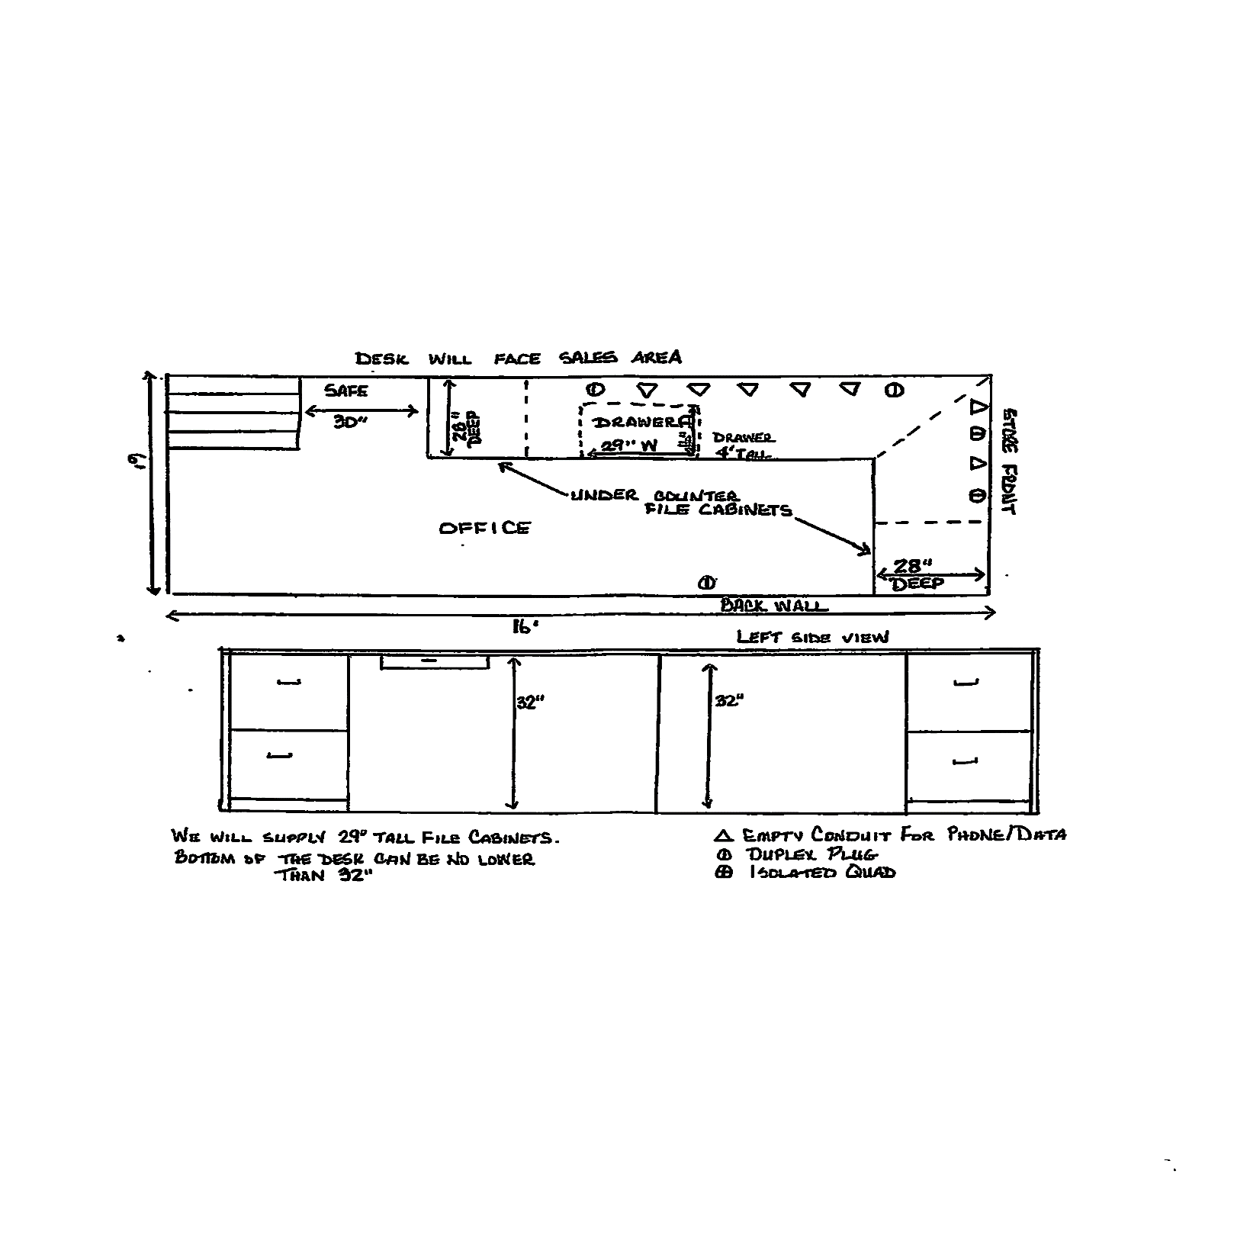

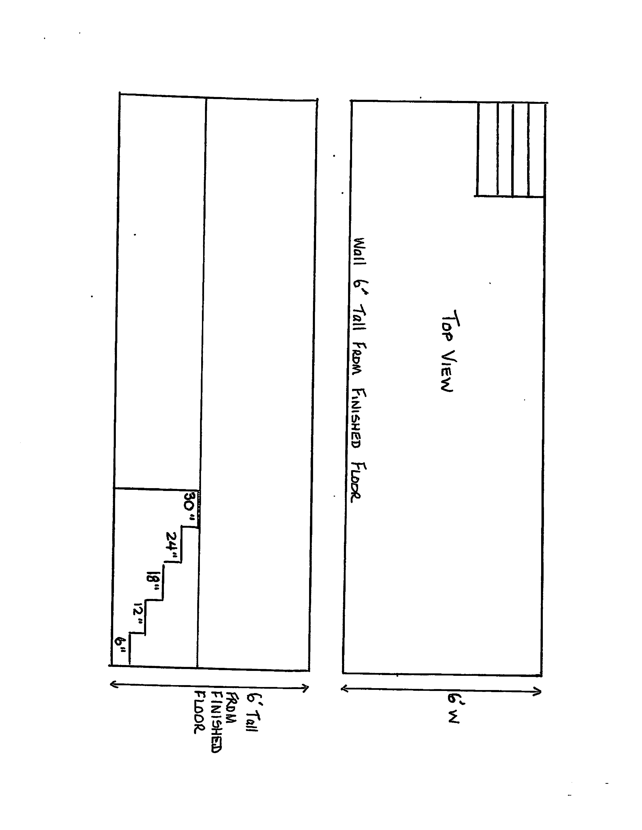

a
STORE FRONT SIGN

(See Attached)

- Furnish, install and maintain "SELECT ABC SPIRITS" signs. The size of signs will be to local code; however, "SELECT ABC SPIRITS" design as attached must be adapted. Accepted sign sizes are:
15' for Store Front 33'
16'6" for Store Front 33' -44'
18' for Store Front 44'+

- These signs will be controlled with dusk to dawn photo-cell direct wire to panel. (NOTE: NO TIMERS)

- Lights in sign must be LED

- A pole sign or marquee will be required if the building visibility is limited from the street. The pole will need to be 20'- 40' high (depending on the surrounding area.)

- Final design must be approved by ABC Real Estate Division. Sign must be up and operational one week before acceptance of store.

NOTE: In the event that ABC vacates the premises, the Landlord is required to have all ABC SIGNAGE removed within 30 days of termination.

AWNING

(See Attached)

- Metal awning must cover all windows and doors of sales area. Must extend 5' from building.

- Adequate lighting should be installed under awning.

- Awning should be a bronze color.

